Service Platform

Contents

Types of Services 2

Business & Customer 2

B2B 3

B2C 3

Business Aggregator 3

Customer to Customer 3

Wireframe 4

Onboarding Process 4

B2C 4

B2C Wireframe 5

Screens for each feature 5

Change History 6

# Types of Services

## Business & Customer

The Service platform will take into consideration various types of service architectures outlined in the wireframe diagram below.

* Banking information will be saved in a separate table AuthBanking. This will have a relationship with parent AuthUsers.

There will be core features common to all platforms like the ability to log in and post site-wide content. Other features include but are not limited to:

* Login as Business
  + Post Articles, Events, About, etc.
* Customer Registration & Login
  + Customize profile
  + See past invoices, receipts, purchase & payment history
  + Bank and Payment Information: Separate Table
  + Short-list Vendors
  + Post Requirements
* Vendor Registration & Login
  + Customize Profile
    - Service/Products Page
    - Hours of Availability
    - Rate
  + Short-list Customers
* SLA Forms
  + Initiate a contract
  + Receiving Party to sign
  + Sending Party to sign
  + Contract Completion
* Billing
  + Estimate
    - Vendor
    - Customer
    - Invoice Name
    - Description
    - Invoice Items (Child Records)
    - IsInvoice
  + Recurring Charges
  + Penalties and Discounts
* Refunds/Discounts/Cash-backs
* Product & Service Inventory
  + Categories & Search Keywords
* Shopping Cart
  + Save Current Session
  + Add to Cart as Anonymous User & Transfer to Cart upon Login
  + Cart Updated with available items (If item is no longer available or price changed, cart must be updated)
* Payment Gateway
  + Stripe
  + Adyen
* Customer Support
  + Initially internal staff
  + Chat features utilizing WebRTC

### B2B

In a business-to-business service, a business will provide services to other businesses that require a higher level of service than average customers.

* Payment Gateway

### B2C

Business to Customer type service will be similar to an ecommerce website where products and services are being sold from a single business to the customer.

### Business Aggregator

Business Aggregator to Customer type service will have Vendors aggregated to provide various categories of services. Freelancers can utilize this service as service providers same as vendors.

### Customer to Customer

Customer to Customer type service will be akin to social media sites, matchmaking sites or clubs or organisations.

## Wireframe

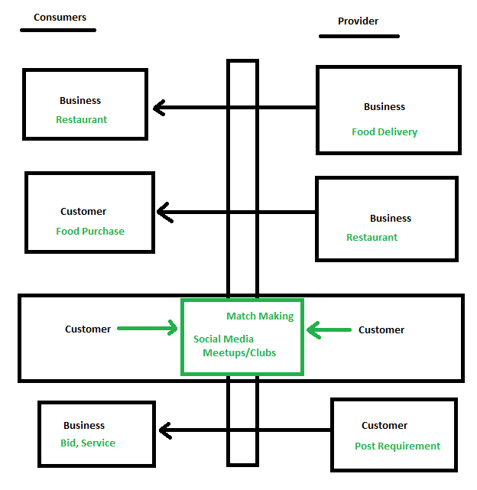

# Onboarding Process

## B2C

* Speak to customer service (Discuss services, answer questions)
* Create an account on the website (AuthUsers)
* Receive and sign contracts (offer valid for 1 week) (Services à ContractDocs) à
  + Receive fully executed contracts in email
* Estimates à Invoice à Tracking
  + Estimate Approval à Invoice
  + Initial Funding (Deposit)
  + Project
    - Tasks
      * Steps/Communication
    - Feedback/Rating
* Payments

### B2C Wireframe

The wireframe below represents a Business to Customer service model

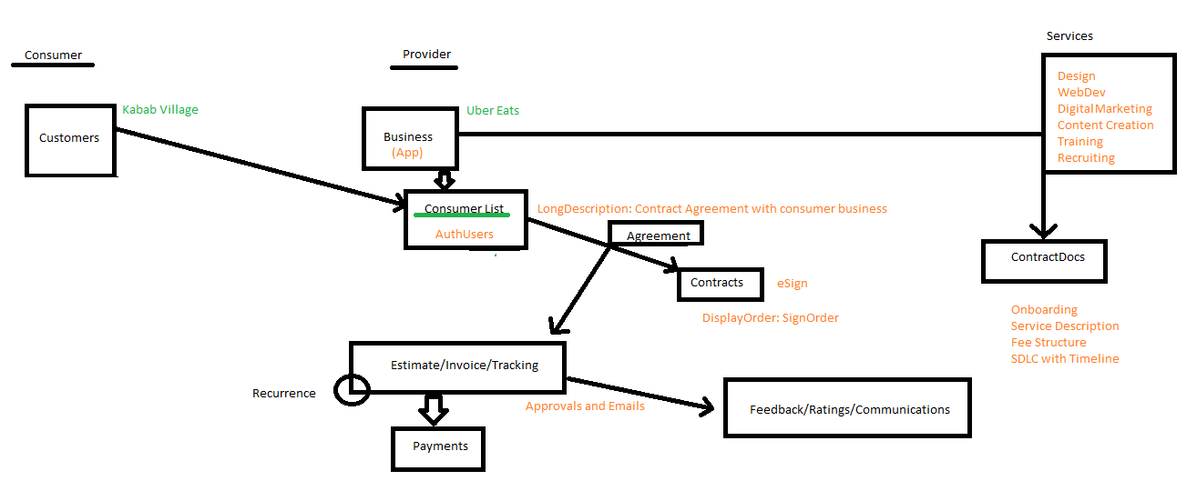

### Screens for each feature

* Manage My Customers (AuthUsers à Role=Customer)
  + Customers Manage own profile, password, etc.
* Category
  + Multiple categories of **ContractDocs**
    - Same field as Image. If condition: PDF or DOCX à THEN show doc thumbnail image
* **Agreement**
  + Title, Short, Long, File
  + **If IsActive** then customer can see the agreement and will receive an email requesting review and eSign
  + Services offered
    - Provider can add, delete or modify documents
    - Once Consumer approves (eSign), email will be sent to preserve integrity
  + Auto-Add **Contract Documents** based on services offered (DISTINCT docs – No dups)
* Estimate form with additional children for “Tasks” or “Items”
  + Main screen will have an aggregate total of items
  + Child items will have entries with details of the items
* Once the estimate is approved, it automatically becomes an Invoice (IsDefault at project level)
* Tracking of the project will be based on the dates committed to in the estimate
  + As soon as an activity is marked “Completed” (IsDefault at the “Item” level), customer will be able to view progress
* Rating and Feedback can be entered per task and per project
* Once work is completed, remaining payments will be due and a grace period will be given before flagging the payment as overdue.
  + All Overdue payment reminders will be emailed to the customer monthly. (Amount > 0)
  + Provider can mark an invoice by clicking “IsDeleted” which will show up as “Paid”. This setting will remove the customer from the Reminders list. Grace period will be saved at the Agreement level

# Change History

|  |  |  |  |
| --- | --- | --- | --- |
| Author | Date | Change | Version |
| Umar | 11/30/2022 | Initial Document | 1.0.0 |
|  |  |  |  |